CRUSADERS FORGE
Custom Weightlifting Belt Order Form
Emai: Crusadersforge@outlook.com
Phone: (325) 201-1953
www.crusadersforge.com

Customer Information
Full Name: _________________________________________
Email Address: _____________________________________
Phone Number: _____________________________________
Shipping Address:
________________________________________________________
________________________________________________________

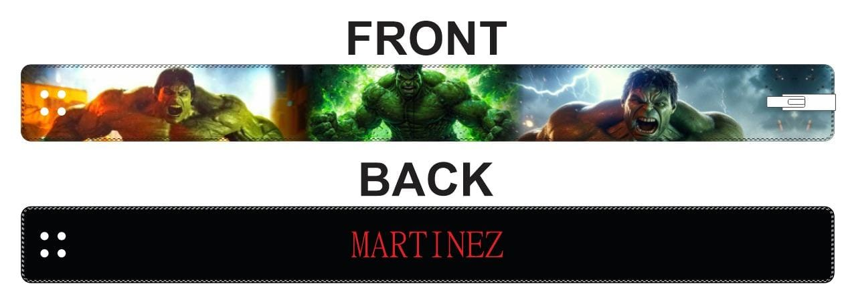

Belt Specifications (Powerlifting 10 MM)
1. Belt Size (measure around your belly button tight)
☐ XS (24–31")
☐ S (26–33")
☐ M (30–36")
☐ L (34–41")
☐ XL (38–45")
☐ XXL (42–50")
☐ Custom Size: _____________

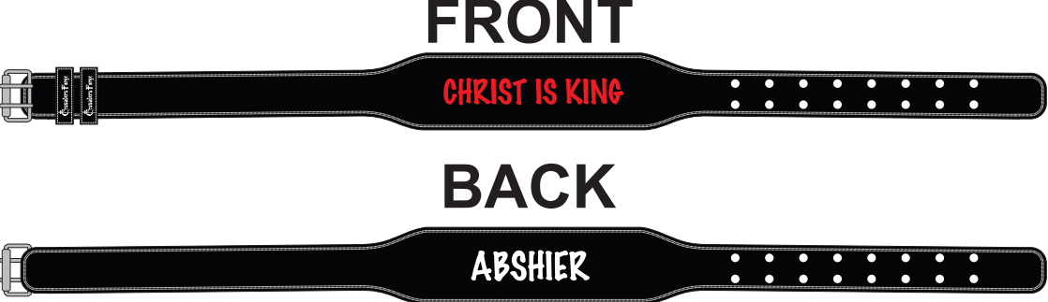
3. Belt Specifications (Weightlifting 7 MM)
Belt Size (measure around your belly button tight)
☐ XS (23–30")
☐ S (27–34")
☐ M (31–38")
☐ L (35–41")
☐ XL (39–44")
☐ XXL (42–48")
☐ XXL (42–48")
☐ Custom Size: _____________
4. Material
☐ Premium Leather
☐ Suede
5. Buckle Type
☐ Lever (Heavy Duty) Number _________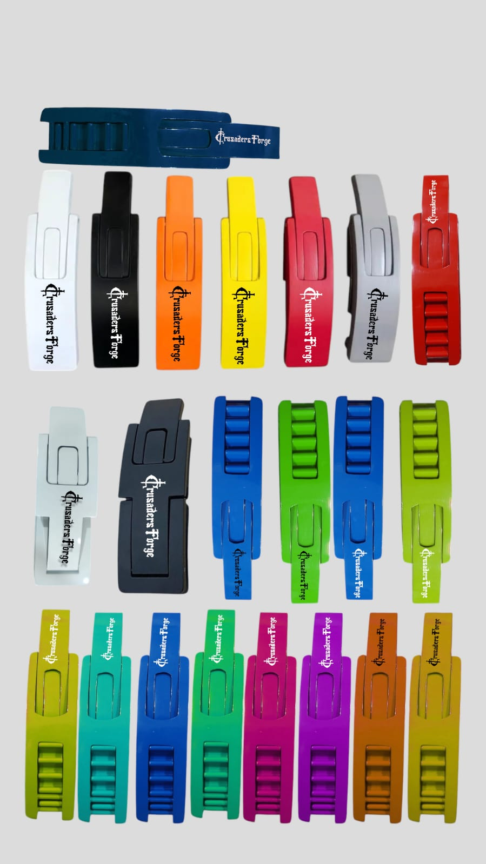
☐ Prong (Single)
☐ Prong (Double)
6. Lever Color (for lever option)
☐ Black
☐ Silver
☐ Gold
☐ Red
☐ Blue
☐ Turquoise
☐ Other: __________________
7. Stitching Color
☐ Black
☐ White
☐ Red
☐ Blue
☐ Custom: ________________

Customization Details
8. Text on Belt:
Front : _______________________________________
Back: _________________________________________________
9. Font Style / Lettering:
☐ Block
☐ Script
☐ Gothic
☐ Other: __________________
10. Logo or Artwork (Attach file or describe)
☐ Yes – Attached
☐ No
Description or Notes:
________________________________________________________
11. Color Theme (base color, accents, logos, etc.):
________________________________________________________

Additional Notes
____________________________________________________________________
____________________________________________________________________

Order Summary
Estimated Total Price: $__150________
Deposit (if required): $__________
Estimated Production Time: _4 - 6__ weeks
Approved By (Initials): ________

Payment Method
☐ Credit Card ☐ PayPal ☐ Cash ☐ Other: ________________

Submit Your Order
Please email completed form and any logo files to: Crusadersforge@outlook.com
OR bring it in to: Crusaders Forge Nutrition – 4238 Sherwood Way, San Angelo, TX

